SIMATS ENGINEERING
ASSESSMENT TOOL 2

COURSE NAME: Artificial Intelligence COURSE CODE: CSA1715

COURSE OUTCOME COVERED
CO1: Apply AI basics such as intelligent agents and uninformed search methods to
solve problems effectively. (BL3)
Assessment Tool Weightage: 2%

QUESTIONS: 3 Duration : 45 min
Total Marks:30
Annexure A
CONSTRAINT BASED PROMBLEM SOLVING

Code of Conduct:
I Vidhya.R(192572153 )(Name / Reg No) certify that this submission is my original work and that I have adhered to the guidelines specified for this assessment.I understand that any violation of academic integrity rules will result in disciplinary action.
Signature of the student:
Vidhya.R

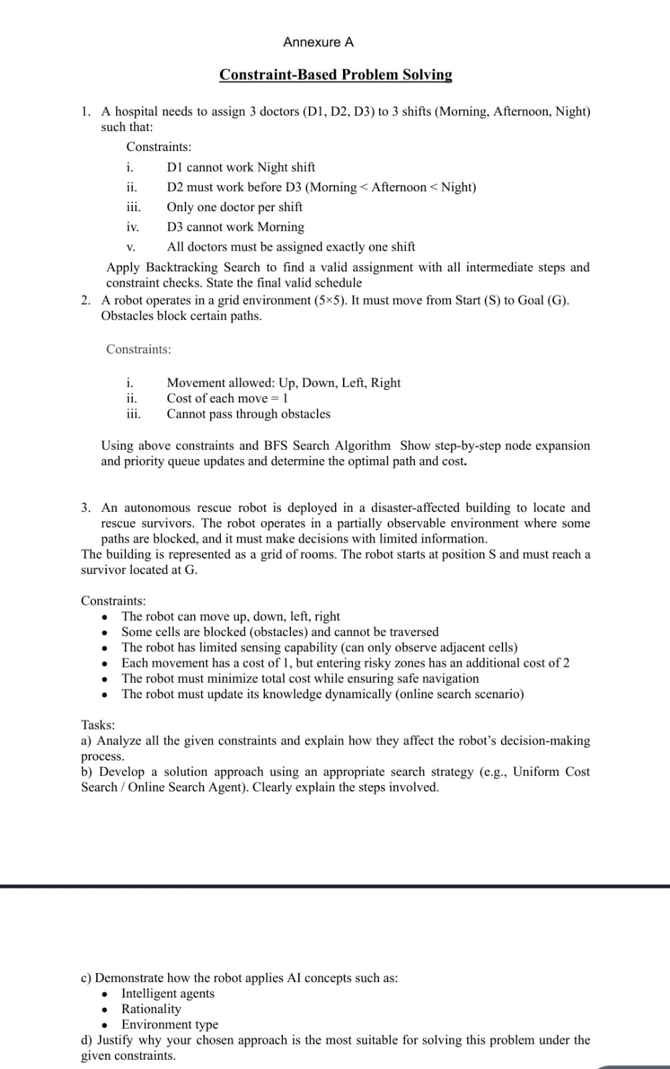
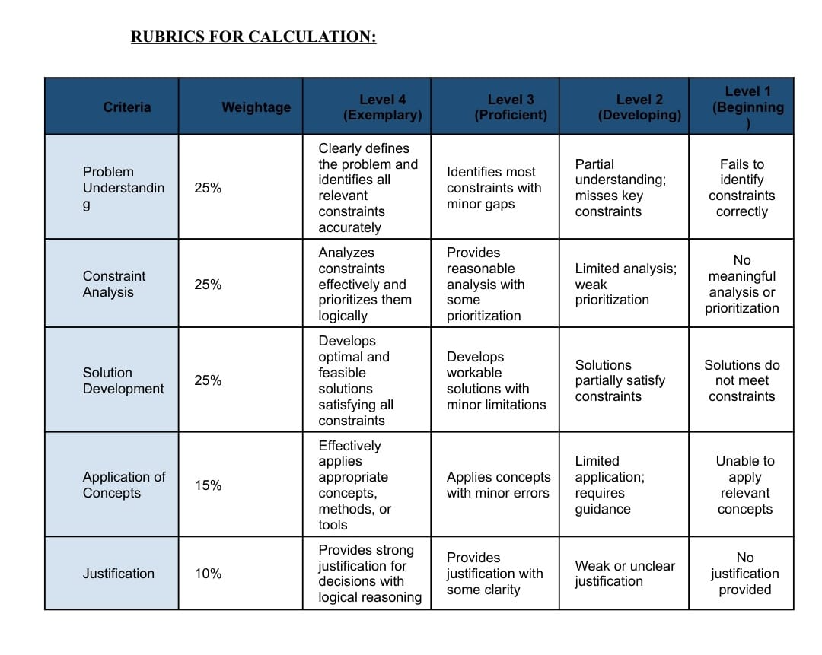
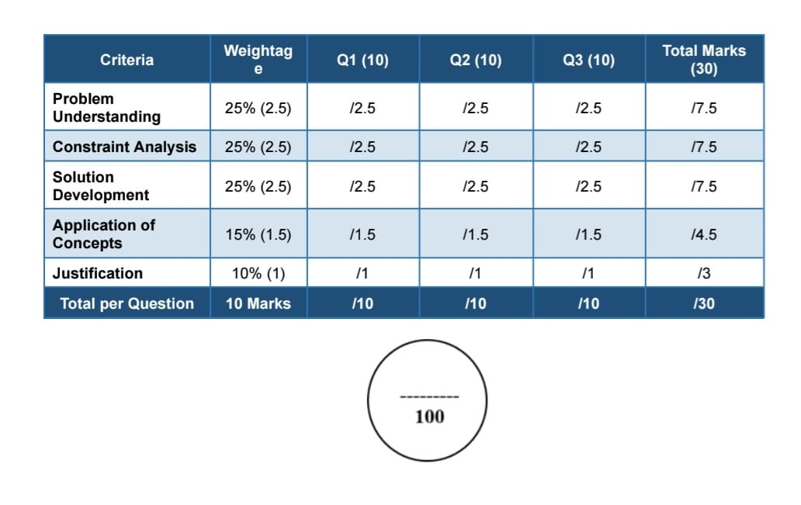
CONSTRAINT BASED PROMBLEM SOLVING:
Question 1: Doctor Shift Scheduling Using Backtracking

Problem Statement:
A hospital needs to assign three doctors (D1, D2, D3) to three shifts (Morning, Afternoon, and Night) while satisfying the given constraints.

Constraints
- D1 cannot work in the Night shift.
- D2 must be assigned before D3 (Morning < Afternoon < Night).
- Only one doctor is allowed in each shift.
- D3 cannot work in the Morning shift.
- Every doctor must be assigned exactly one shift.

Backtracking Steps:
Step 1: Assign D1 → Morning.
This assignment satisfies the first constraint.
Current Assignment
- D1 → Morning
Step 2: Assign D2.
- Morning → Not possible (already assigned to D1)
- Afternoon → Assigned
Current Assignment
- D1 → Morning
- D2 → Afternoon
Step 3: Assign D3
- Morning → Not allowed
- Afternoon → Already occupied
- Night → Assigned

Constraint Checking
- D1 is not in the Night shift
- D2 is scheduled before D3
- Only one doctor is assigned to each shift
- Every doctor has exactly one shift
Final scheduling:
DOCTOR | SHIFT
D1 | morning
D2 | afternoon
D3 | night
Question 2: Robot Navigation Using BFS

Problem Statement:
A robot moves in a 5 × 5 grid from the Start (S) position to the Goal (G). Some cells contain obstacles.

Constraints:
- The robot can move only Up, Down, Left, and Right.
- Cost of each move = 1.
- Obstacles cannot be crossed.

BFS Algorithm Steps:
- Start from node S
- Add the starting node to the queue.
- Visit all unvisited neighbouring nodes.
- Ignore blocked cells.
- Continue expanding nodes level by level.
- Stop when the Goal (G) is reached.

Node Expansion:
Initial Queue:
[S]
After expanding S:
[(0,1), (1,0)]
After expanding (0,1):
[(1,0), (0,2)]
After expanding (1,0):
[(0,2), (2,0)]
The process continues until the Goal node is reached.

Optimal Path:
S → (0,1) → (0,2) → (1,2) → (2,2) → (3,2) → (4,2) → (4,3) → G

Cost:
- Number of moves = 8
- Cost per move = 1
- Total Cost = 8

Result:
BFS finds the shortest path because every move has the same cost.
Question 3: Rescue Robot Problem:

A)Effect of Constraints:
- The robot cannot move through obstacle cells.
- It can move only in four directions.
- The robot has limited sensing and can observe only nearby cells.
- Entering risky areas increases the total travel cost.
- The robot updates its path whenever new information is available.
b) Solution Using Uniform Cost Search
- Start from the initial position (S).
- Observe the neighbouring cells.
- Calculate the cost of every possible move.
- Select the path with the lowest total cost.
- Ignore blocked paths.
- Update the map whenever a new obstacle is detected.
- Repeat the process until the robot reaches the Goal (G).

c) AI Concepts

Intelligent Agent:
The robot senses the environment, processes the information, and selects the best action to reach the goal.

Rationality:
The robot always chooses the safest path with the minimum cost.

Environment Type:
- Partially Observable
- Dynamic
- Sequential
- Discrete
- Single-Agent

d) Justification:
Uniform Cost Search is suitable because it always chooses the path with the lowest total cost. It avoids risky and blocked areas while updating its decisions whenever new information is available. Therefore, it helps the robot safely reach the survivor in a disaster environment.

Conclusion:
The robot successfully reaches the goal by following the least-cost path while satisfying all the given constraints.
This format can be copied directly into Microsoft Word with headings, bold text, and the table intact for a neat assignment submission.
Top of Form

